**GenSec Industries: Protocol specification document**

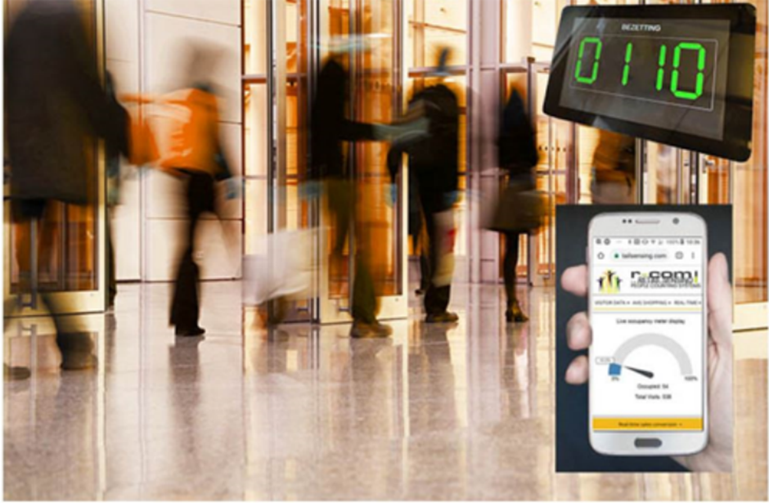  
  
  
  
  
  
  
  
  
  
  
Johnson Domacasse 4471709  
Nedyalko Tenev 4808231  
Tuan Kiet Ho 4832649  
Farros Ramzy 3767353

1. Introduction 2

2. Protocol: 3

2.1: Communication Protocol: 3

2.2: Message table: 3

# Introduction

*The focus of this document is to keep track of all the protocol decisions that were made for the occupancy management system. Information regarding the communication protocol, message tables and any additional information regarding the protocol aspect of the system can be found here.*

# Protocol:

*After the team selects a protocol for communication, please fill this up with relevant information about how will this be achieved, including information about devices required for the communication (e.g. brokers)*

# Messages rules:

*This section of the document will give more information on the communication protocol and why it was chosen. See Analys document more information.*

## 3.1: Communication basis:

## By leveraging a network of sensors and devices, the system allows users to remotely control and monitor various aspects of the security network. It employs a robust communication protocol to ensure seamless data exchange between devices and easy to understand commands that will help with debugging. The communication’s core objective is to create an integrated, efficient, and secure solution.

To implement the desired outcome, multiple rules had to be created. To have a system that will allow us to check the integrity of a message, we need to have a **start and end symbol**.

|  |  |
| --- | --- |
| Start symbol | & |
| End symbol | ; |

To make sure that the difference between command and data is known, we will be using **capital letters to send commands**.

To know which device is communicating in the system, we will have to instance ID’s. Since we do not expect more than 1000 devices connected at the same time, we will operate on **a 3-digit ID** (e.g. 045).

To separate the ID and the rest of the message, a **separation character** must be used. It can also be used in a different instance of a message, whenever needed (e.g. targeted message to a different ID). We will be using a **dash ‘-‘** for our use case.

|  |  |
| --- | --- |
| Separation symbol | - |

**Data in the message will be added using a +**, and if **multiple instances of data need to be added, a comma ‘,’** will be used.

|  |  |
| --- | --- |
| Data add symbol | + |
| Data next symbol | , |

Examples:

&004-OPENGATE-122;

- Divider 004 tells gate 122 to open.

&112-NUMOFPEOPLE+15;

- Gate 112 announces that 15 people are waiting on the line.

&234-ALLOC-021+2;

## 3.2: Message table:

To make sure all devices follow the same commands, a command table is created:

|  |  |
| --- | --- |
|  |  |
| OPENGATE | Requests a gate to be opened. |
| CLOSEGATE | Requests a gate to be closed. |
| NUMOFPEOPLE | Announces amount of people |
| EMERGENCY | Requests all devices to go into emergency mode. |
| ALLOC | Divider sends a certain amount of people to a gate |